**PRESENTED BY:**

**KANWAL SHEHZADI (02-131212-027) AIMAN ZIA SATTI (02-131212-028)**

**DATE : | 23-06-2023**

**LIBRARY MANAGEMENT SYSTEM**

Spring 2023

**TABLE OF CONTENTS:**

* Acknowledgement
* Abstract
* Introduction
* Project Scope
* Tables
* Design Patterns
* Architectural Patterns
* Architecture
* Use-Case Diagram
* ER Diagram
* DB Diagram
* Screenshorts

**ACKNOWLEDGEMENT:**

We would like to extend our sincerest thanks to our teacher “***Engr.Rehan Baig***” for his invaluable guidance and support throughout our semester project. Your expertise, constructive feedback, and patience have played a pivotal role in shaping our project's success. Your willingness to go above and beyond to ensure our understanding and growth has been truly inspiring. We are grateful for the opportunity to learn under your mentorship, and We appreciate the impact you have had on our academic and personal development. Thank you for being an exceptional teacher and for fostering an environment that nurtures creativity and learning.

**ABSTRACT :**

The Library Management System (LMS) is a comprehensive software solution designed to streamline and automate the operations of a library. It serves as a centralized platform for managing various library functions, including cataloging, circulation, acquisition, and user management. The LMS offers an intuitive user interface that facilitates easy navigation and efficient information retrieval, enhancing the overall library experience for both library staff and patrons.

**INTRODUCTION:**

Traditionally, library management involved manual processes such as cataloging books, maintaining borrower records, tracking circulation, and managing overdue fines. These tasks were time-consuming and prone to errors. However, with the advent of technology, library management systems have revolutionized the way libraries function, making these processes more streamlined, accurate, and user-friendly.

A library management system is an indispensable tool for modern libraries, empowering them to adapt to the digital era, optimize their resources, and deliver a seamless and enriching experience to their users. By implementing a library management system, libraries can significantly enhance their operational efficiency, improve user experience, and provide better access to their collections. Librarians can save time on manual tasks, allowing them to focus more on providing valuable services to library patrons. Furthermore, library users can benefit from the convenience of online catalog searching, easy borrowing and returning processes, and personalized recommendations.

**PROJECT SCOPE:**

**CATALOGING AND RESOURCE MANAGEMENT:**

The system should provide a comprehensive cataloging module to efficiently manage library resources. It should allow librarians to input, organize, update, and search for books. The module should support features such keyword-based searching.

**USER MANAGEMENT:**

The system should offer user management capabilities, allowing librarians to create and manage user accounts. It should support user registration, authentication, and access control. The module should enable librarians to track user borrowing history, preferences, and personal information.

**ACCESSIBILITY AND USER INTERFACE:**

The system should offer a user-friendly interface . It should be designed with a clear and intuitive layout, allowing users to easily navigate through catalog search results, check-out procedures, account management, and other system functionalities. The interface should be responsive .

**PROJECT TIMELINE AND DELIVERABLES:**

The scope should define the project timeline, including milestones, deliverables, and key implementation phases. It should outline the resources required, such as hardware, software, and human resources, and estimate the overall project effort.

**BORROWING AND RETURNING:**

Develop a mechanism for patrons to borrow and return books. Include functionalities like issuing library cards, managing due dates, and sending reminders for overdue items.

**REPORT GENERATION:**

The system can generate various reports for record-keeping and review purposes, as per end-user requirements.

**TABLES:**

* Students
* Employees (Admin , Librarian)
* Publishers
* Book
* Book issuance
* Categories
* Library Database
* Author

**DESIGN PATTERNS:**

* Singleton

In the context of a library management system login, the Singleton design pattern can be used to ensure that there is only one instance of the login system throughout the application. The Singleton pattern restricts the instantiation of a class to a single object and provides a global point of access to it.

* Observer

The Observer design pattern can be applied to the sign-in functionality of a library management system to notify other components or modules about the successful sign-in event. The Observer pattern defines a one-to-many dependency between objects, where multiple observers are notified when the subject (observable) undergoes a change.

* Façade

The Facade design pattern can be used to simplify and provide a unified interface for the complex subsystems of a librarian dashboard and an admin dashboard in a library management system. The Facade pattern provides a higher-level interface that hides the complexities of the underlying subsystems, making it easier for clients to interact with the system.

* Decorator

The Decorator design pattern can be applied to enhance the functionality of the admin view of students and the admin view of books in a library management system. The Decorator pattern allows you to dynamically add additional behaviors or features to an object without modifying its underlying structure.

* Strategy

The Strategy design pattern can be applied to the admin view of issued books and returned books in a library management system to provide different strategies for displaying the information. The Strategy pattern defines a family of interchangeable algorithms, encapsulates each one, and makes them interchangeable at runtime.

**ARCHITECTURAL PATTERNS:**

* Repository

The Repository design pattern can be applied to manage the data access and storage for various entities and functionalities in a library management system. It provides an abstraction layer between the data source and the application, allowing the system to perform CRUD (Create, Read, Update, Delete) operations on entities such as categories, publications, authors, staff, students, etc.

* BlackBoard

In a library management system, the Blackboard design pattern can be utilized to manage and update the complete book details and complete return details. The Blackboard pattern is useful when dealing with complex systems that require collaboration between multiple components to solve a problem or make decisions.

**ARCHITECTURE**

* 3 TIER ARCHITECTURE(PRESENTATION LAYER,BUSINESS LAYER,DATABASE LAYER)

The Presentation Layer handles user interface and interaction, displaying library catalog, search functionality, and capturing user inputs.

The Business Layer contains core logic, enforces business rules, manages data flow between layers, and performs operations such as book issuance, returns, and student record management.

The Database Layer stores and manages data, including book details, student records, and transaction history, ensuring data integrity and providing efficient access.

**USE-CASE DIAGRAM:**

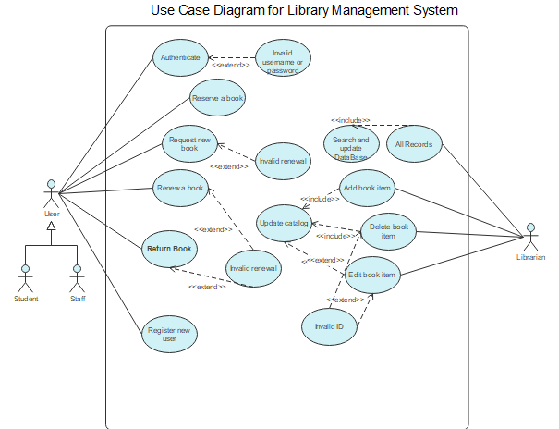

**ER-DIAGRAM:**

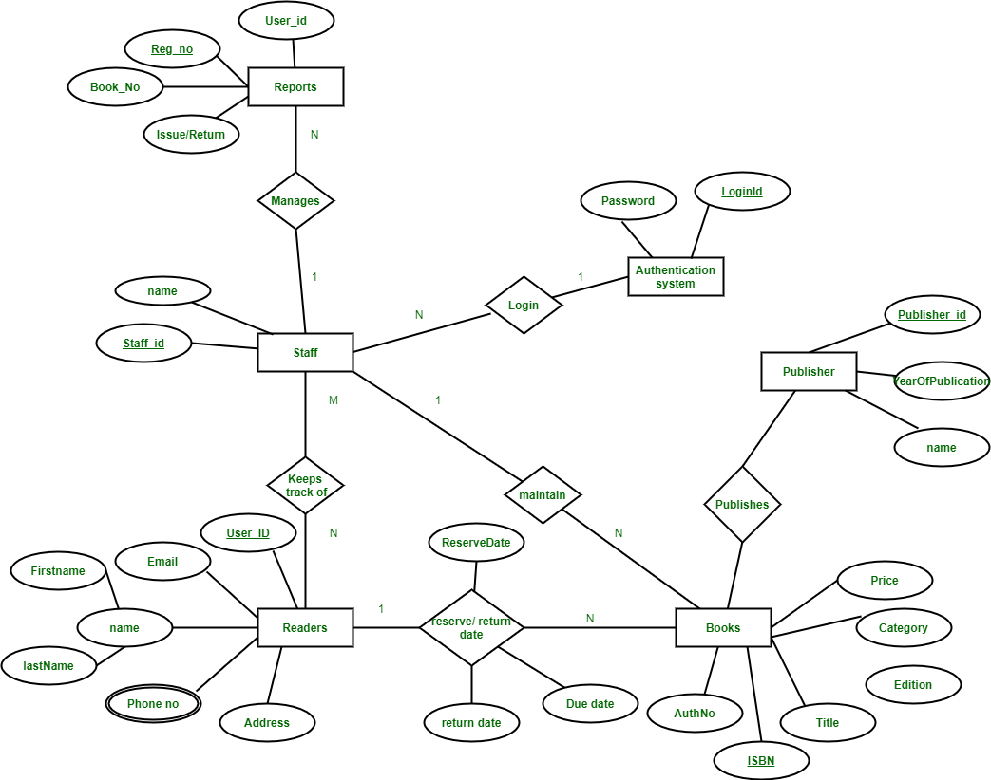

**DB DIAGRAM:**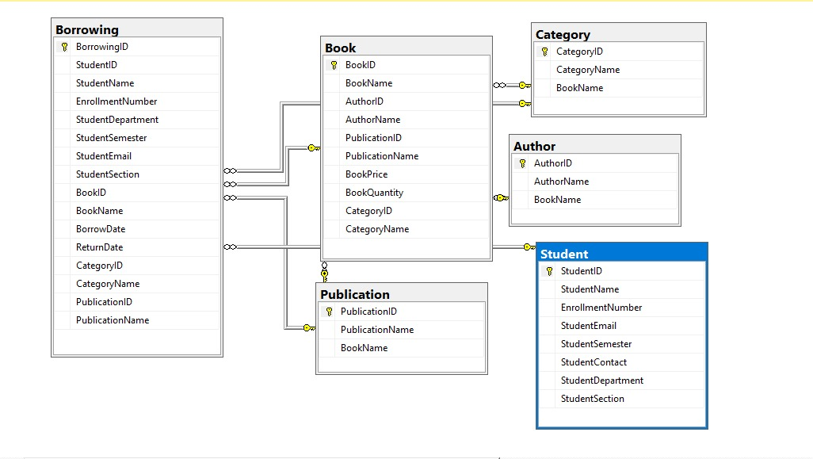

**SCREENSHORTS:**

**SPLASHSCREEN:**

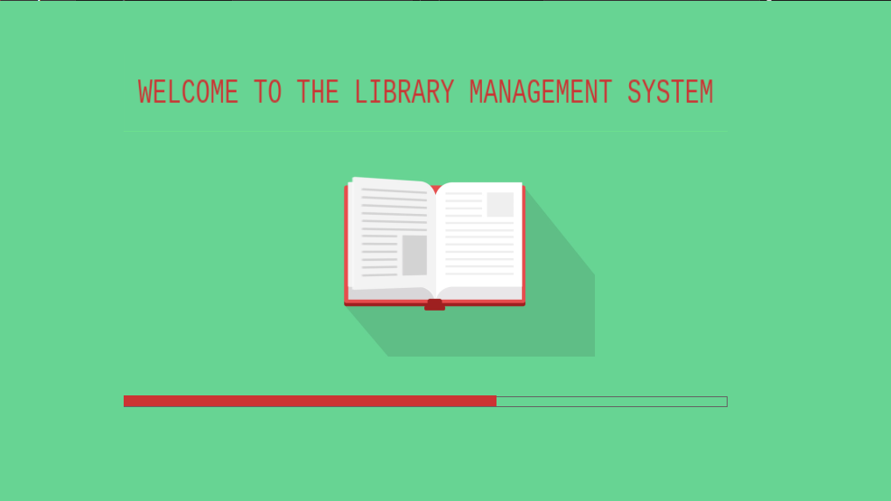

**LOGIN:**

